SQL Hands-on Practice: DDL, DML, DCL, TCL

Database: Bank Management System

Name: Y.Sathwika
Roll No: 2520030007
Section: 7

SECTION 1 — DDL (Data Definition Language)

Step 1 — CREATE TABLE

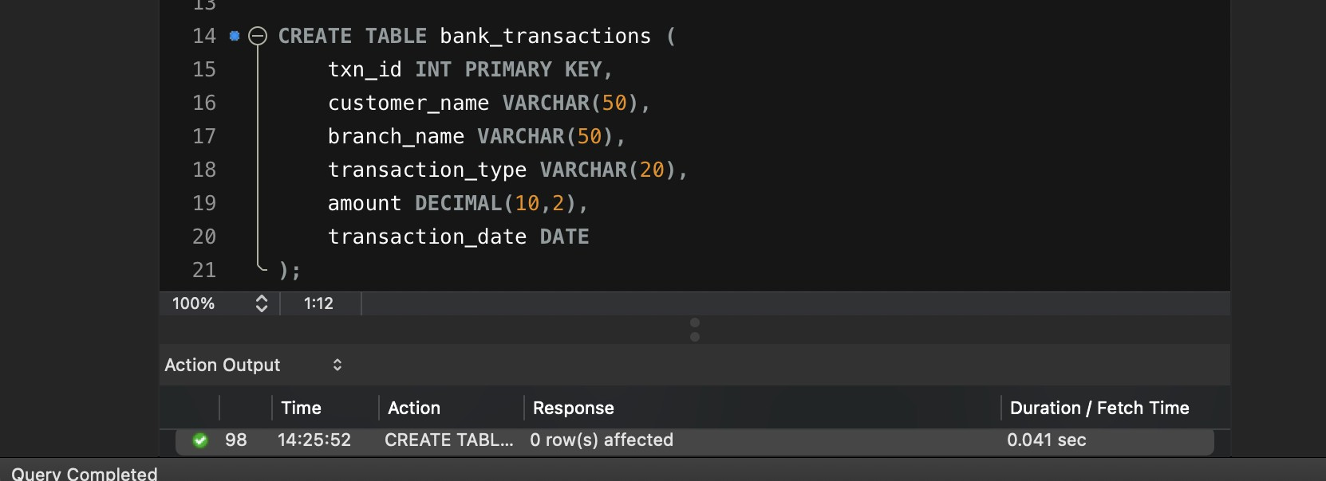
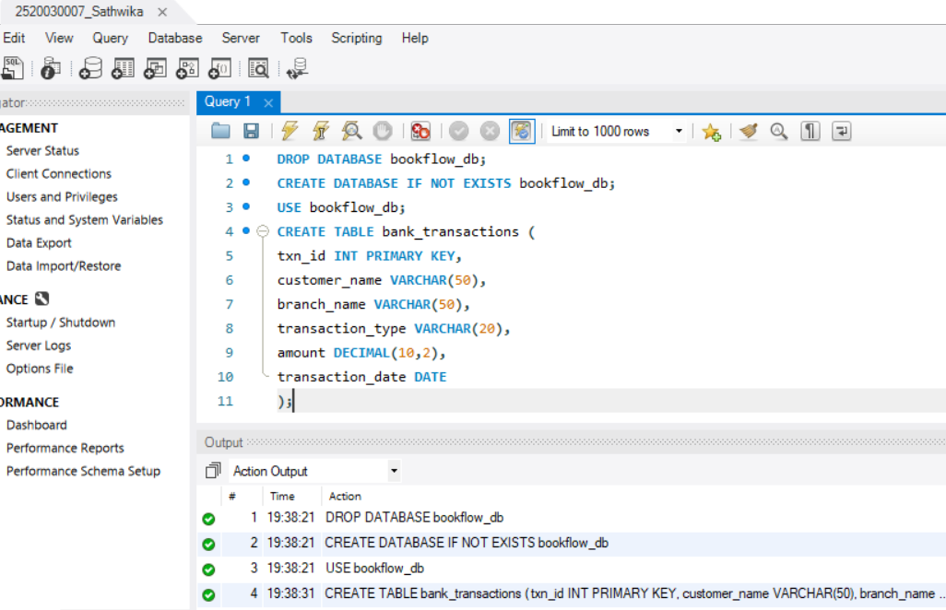
CREATE TABLE bank_transactions ( txn_id INT PRIMARY KEY, customer_name VARCHAR(50), branch_name VARCHAR(50), transaction_type VARCHAR(20), amount DECIMAL(10,2), transaction_date DATE
);

Step 2 — ALTER TABLE — ADD COLUMN

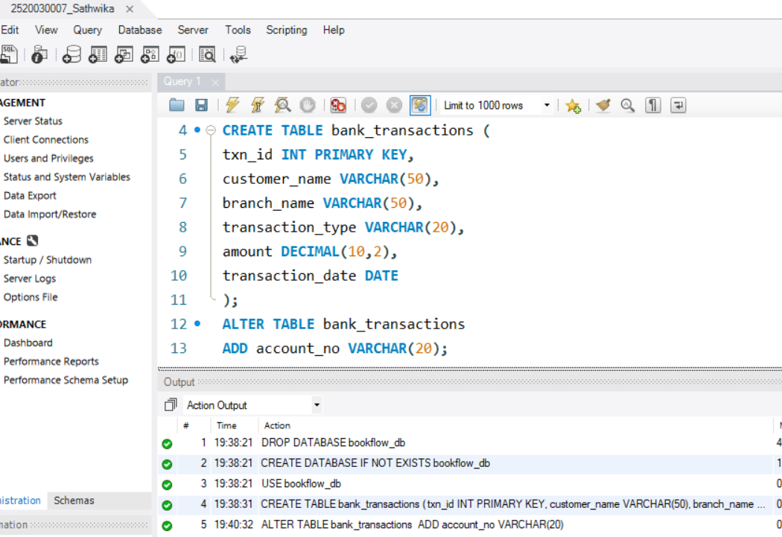

Step 3 — ALTER TABLE — MODIFY COLUM 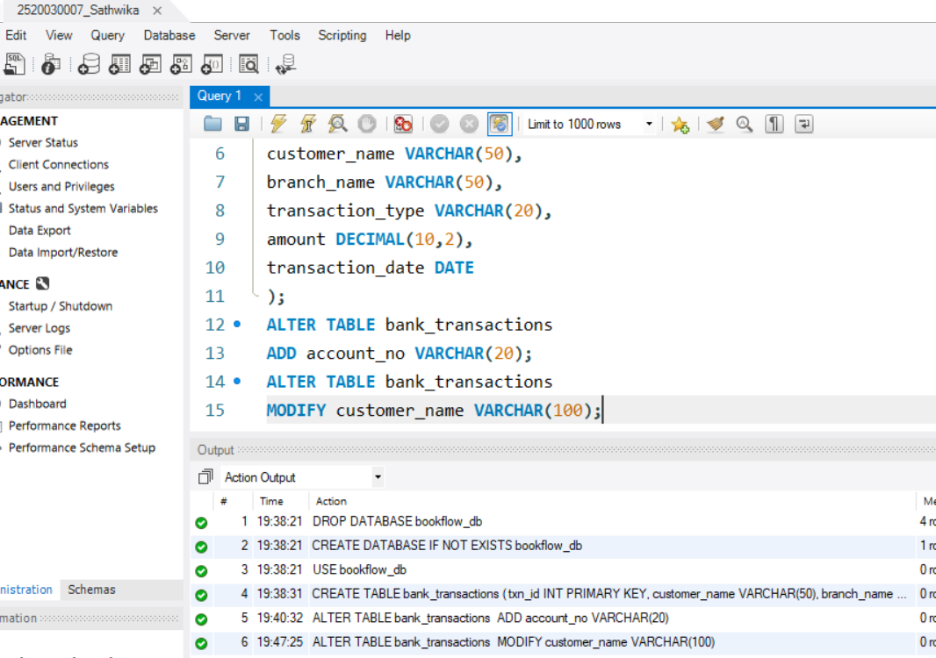
ALTER TABLE bank_transactions MODIFY customer_name VARCHAR(100);

Step 4 — TRUNCATE TABLE
TRUNCATE TABLE bank_transactions;

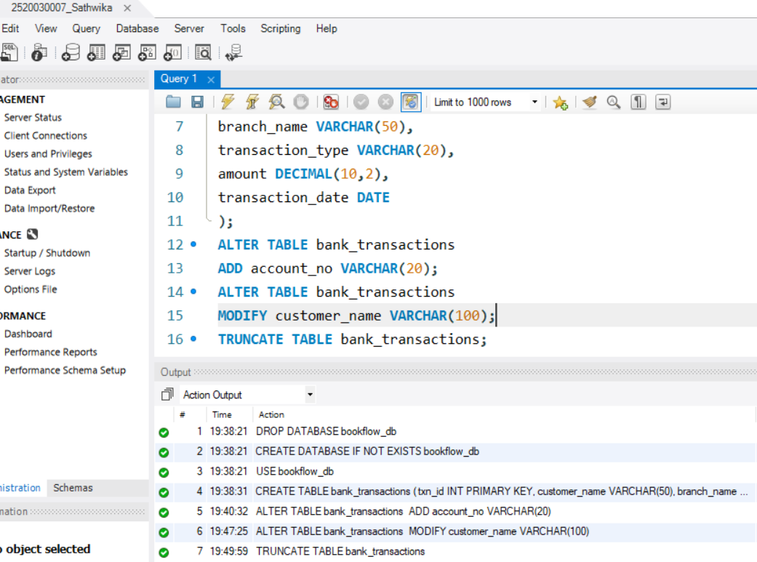

Step 5 — DROP TABLE
DROP TABLE bank_backup;
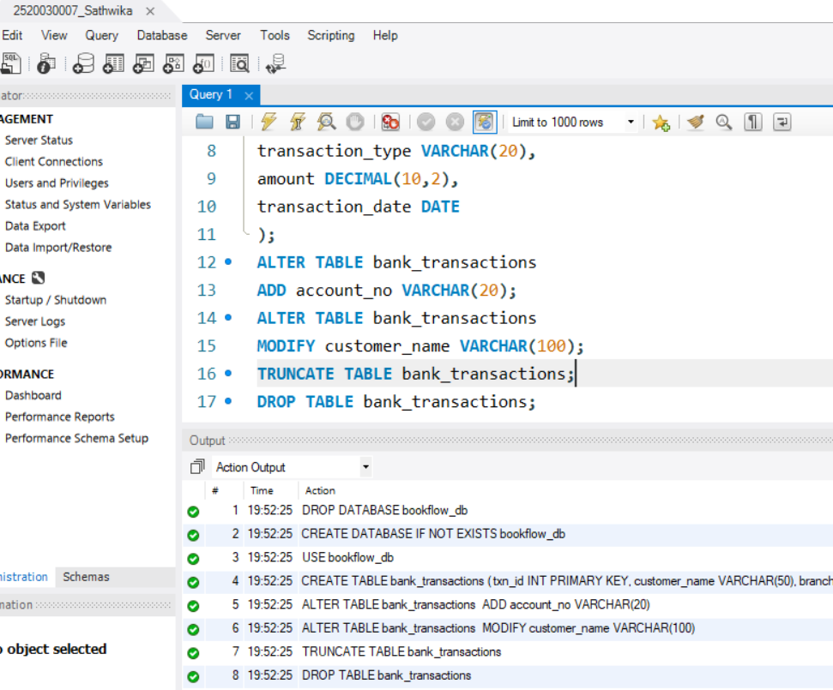

SECTION 2 — DML (Data Manipulation Language)

Step 6 — Insert Sample Data (10 rows)
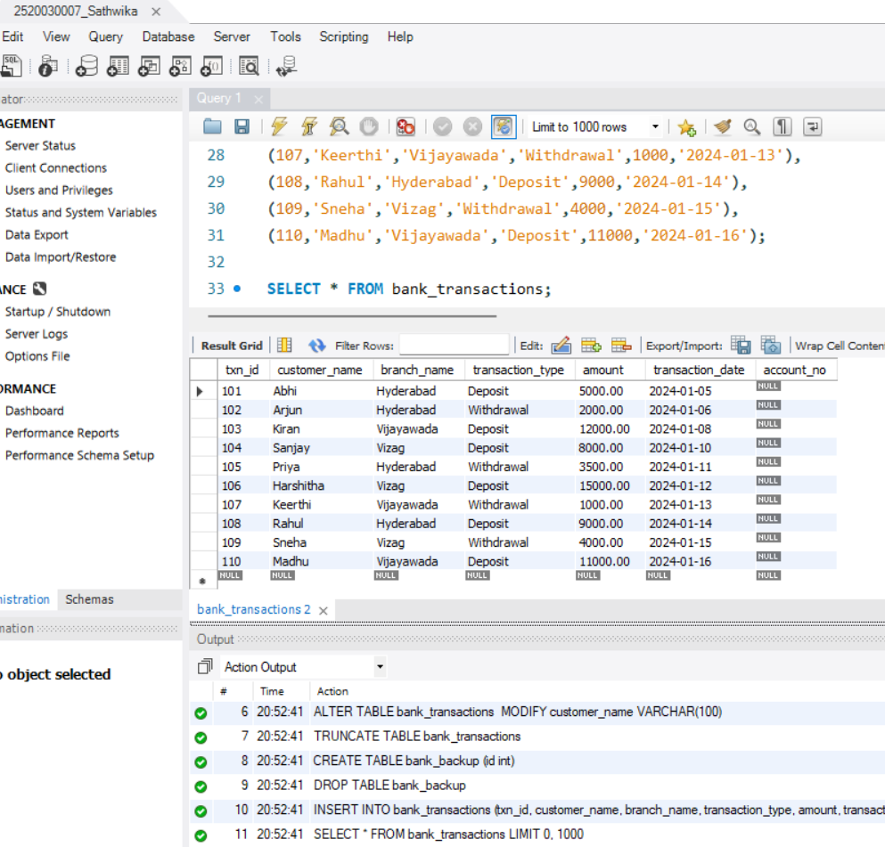
INSERT INTO bank_transactions VALUES (101,'Abhi','Hyderabad','Deposit',5000,'2024-01-05'),
(102,'Arjun','Hyderabad','Withdrawal',2000,'2024-01-06'),
(103,'Kiran','Vijayawada','Deposit',12000,'2024-01-08'),
(104,'Sanjay','Vizag','Deposit',8000,'2024-01-10'),
(105,'Priya','Hyderabad','Withdrawal',3500,'2024-01-11'),
(106,'Harshitha','Vizag','Deposit',15000,'2024-01-12'),
(107,'Keerthi','Vijayawada','Withdrawal',1000,'2024-01-13'), (108,'Rahul','Hyderabad','Deposit',9000,'2024-01-14'),
(109,'Sneha','Vizag','Withdrawal',4000,'2024-01-15'),
(110,'Madhu','Vijayawada','Deposit',11000,'2024-01-16');

Step 7 — INSERT

INSERT INTO bank_transactions VALUES
(111,'Preetish','Vizag','Deposit',7000,'2024-01-18', ‘ACC111’);

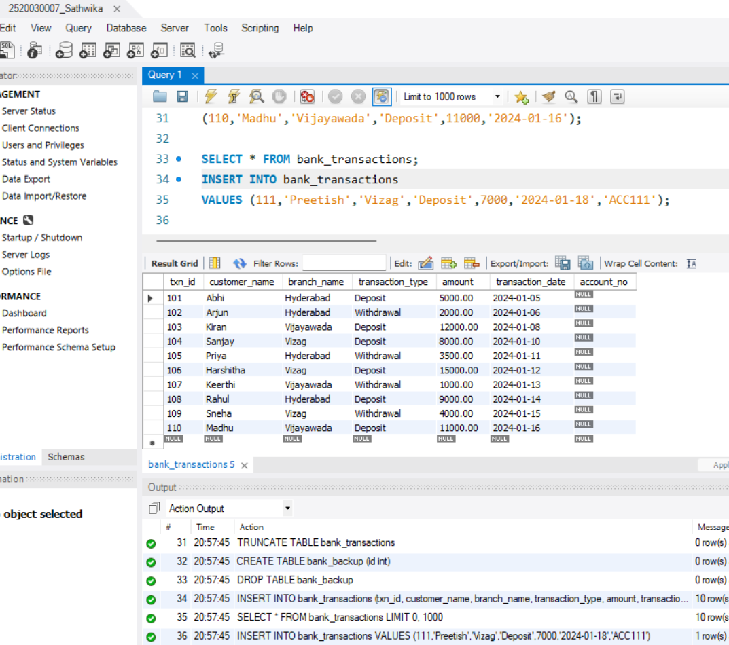

Step 8 — UPDATE
UPDATE bank_transactions SET amount = 5000
WHERE txn_id = 105;

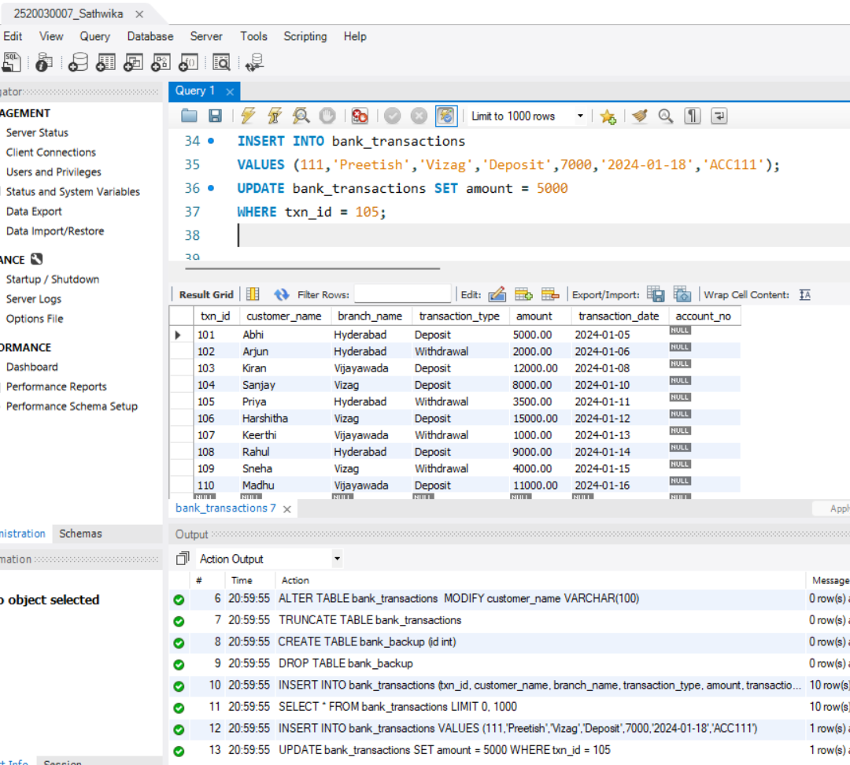

Step 9 — DELETE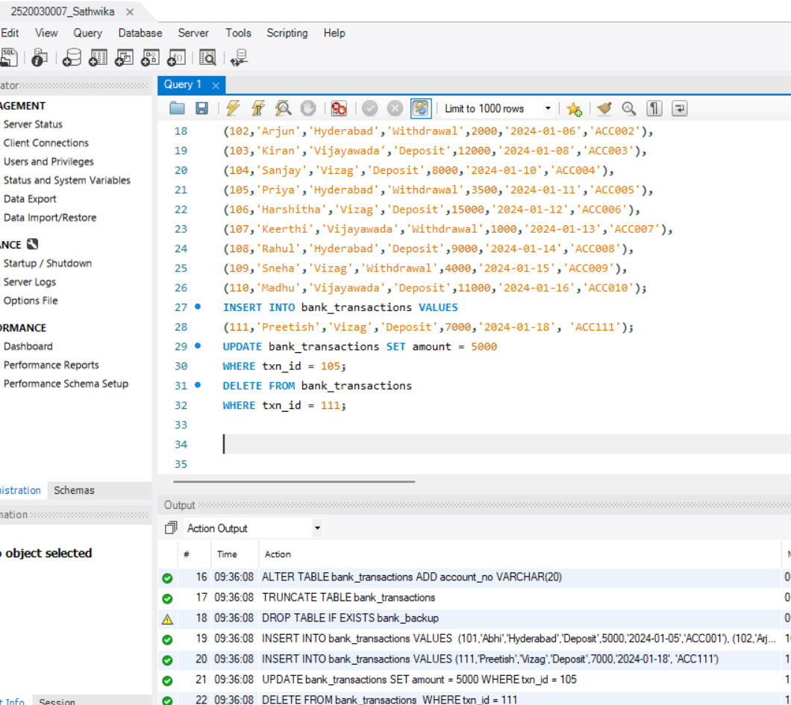

Step 10 — SELECT (All Rows)
SELECT *
FROM bank_transactions;

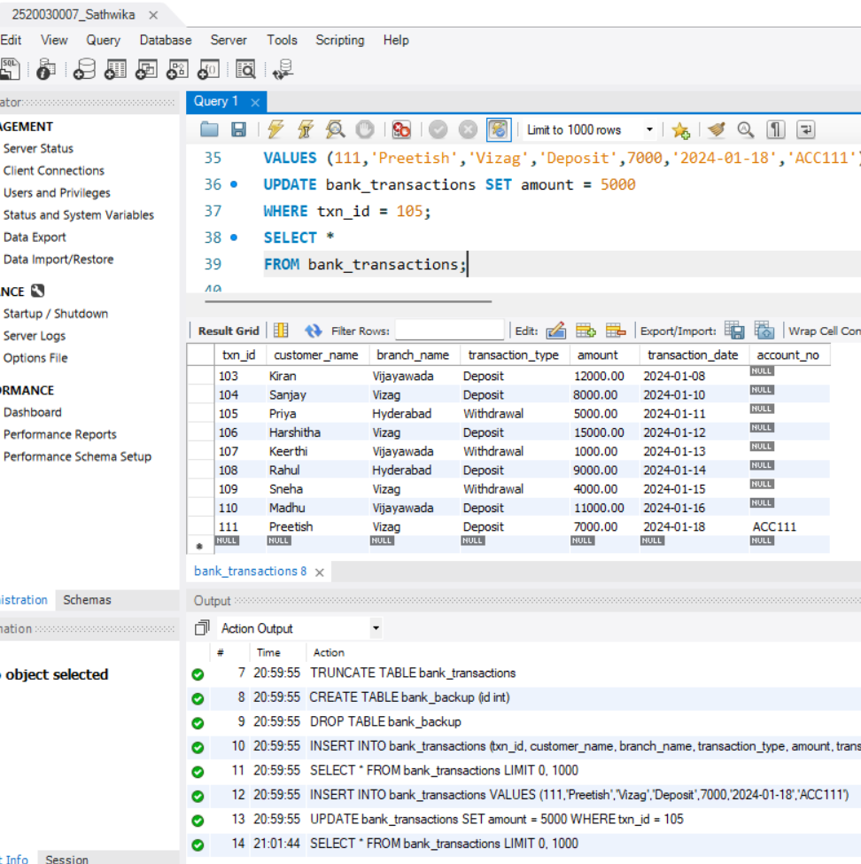

Step 11 — SELECT WITH WHERE
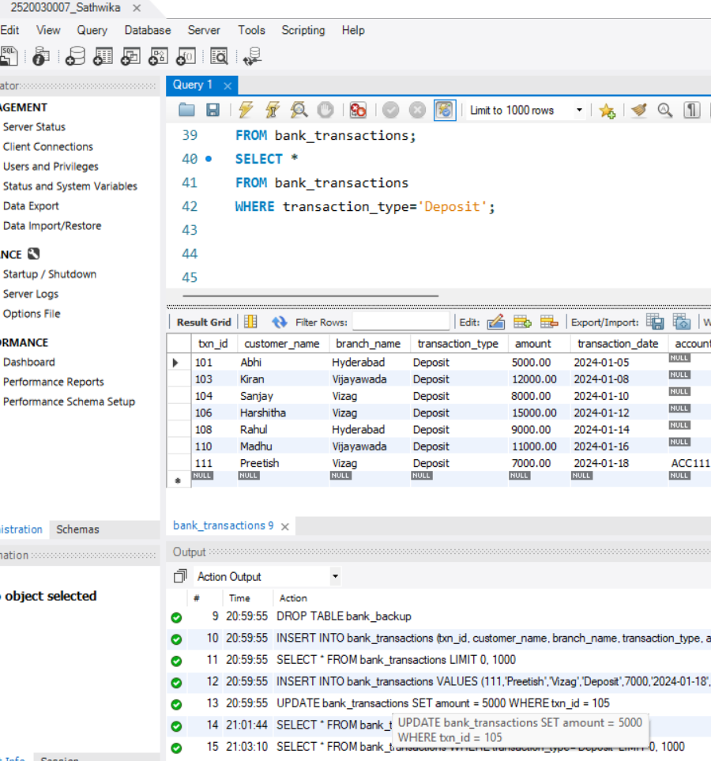
SELECT *
FROM bank_transactions
WHERE transaction_type='Deposit';

Step 12 — SELECT WITH ORDER BY
SELECT *
FROM bank_transactions ORDER BY amount DESC;

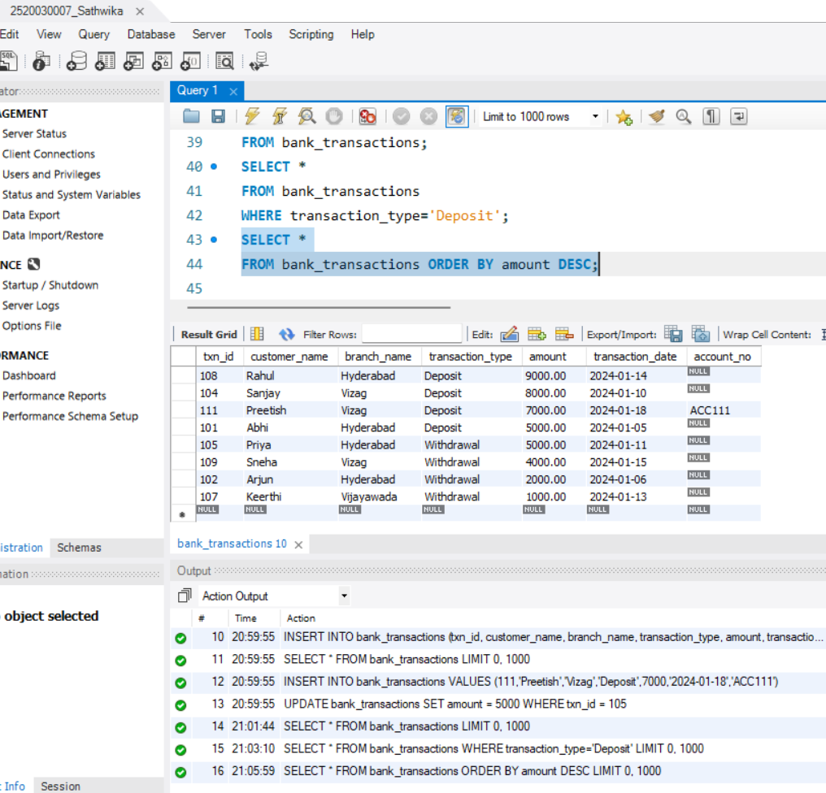

Step 12 — SELECT WITH ORDER BY
SELECT *
FROM bank_transactions ORDER BY amount DESC;

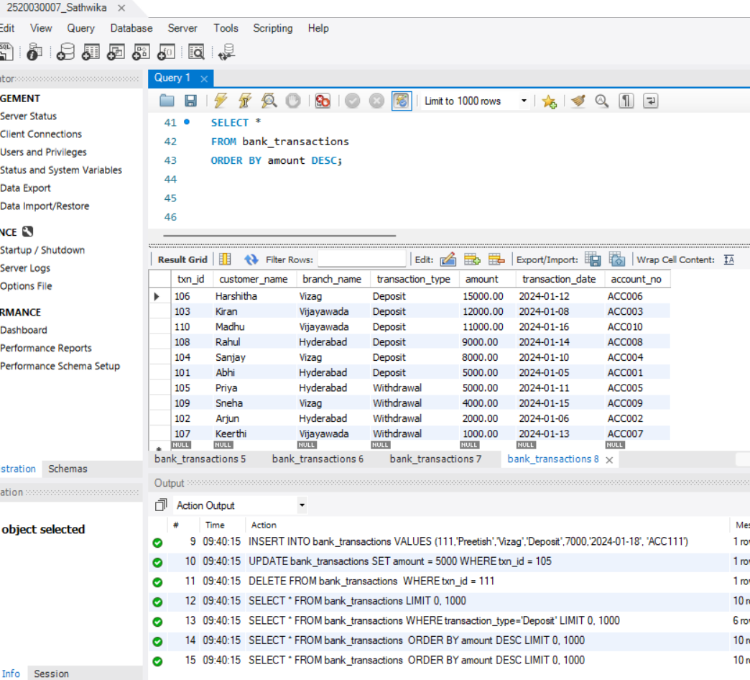

SECTION 3 — DCL (Data Control Language)

Step 13 — GRANT SELECT
GRANT SELECT
ON bank_transactions TO Auditor1;

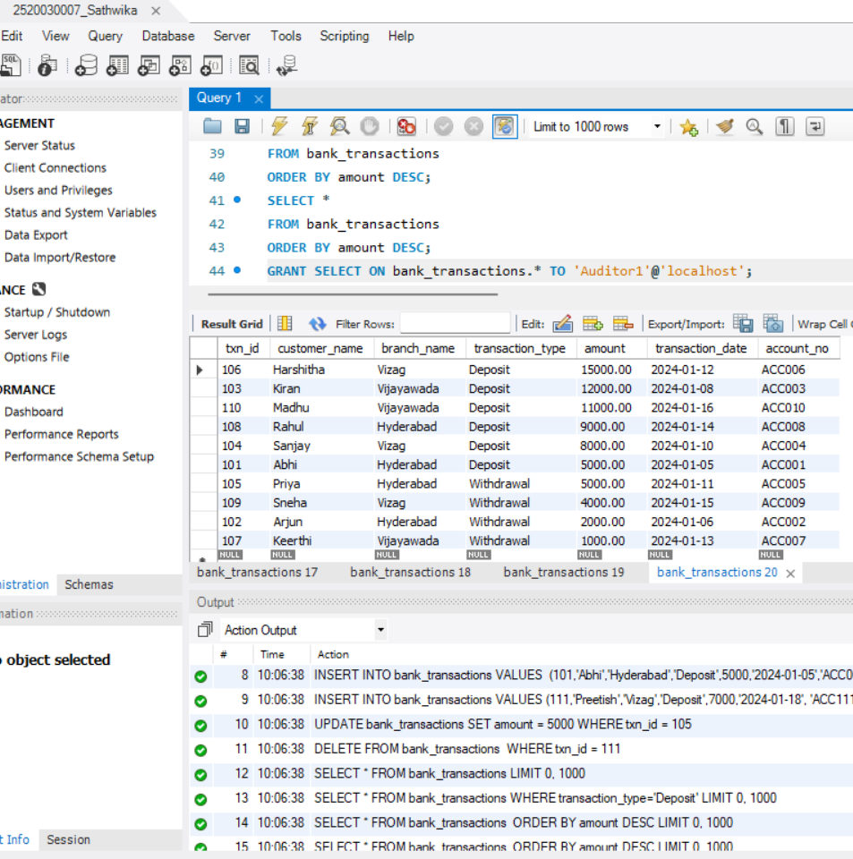

Step 14 — GRANT ALL PRIVILEGES
GRANT ALL
ON bank_transactions TO BranchManager;
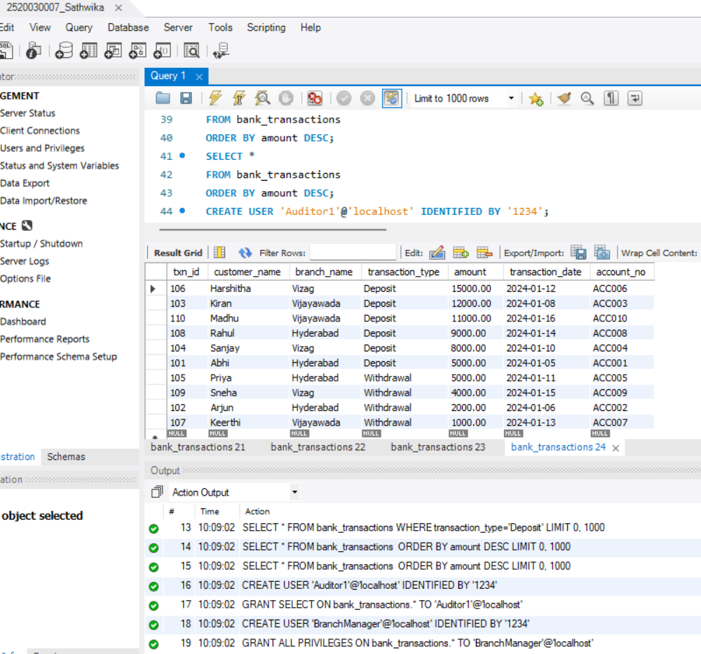

Step 15 — REVOKE SELECT
REVOKE SELECT
ON bank_transactions FROM Auditor1;

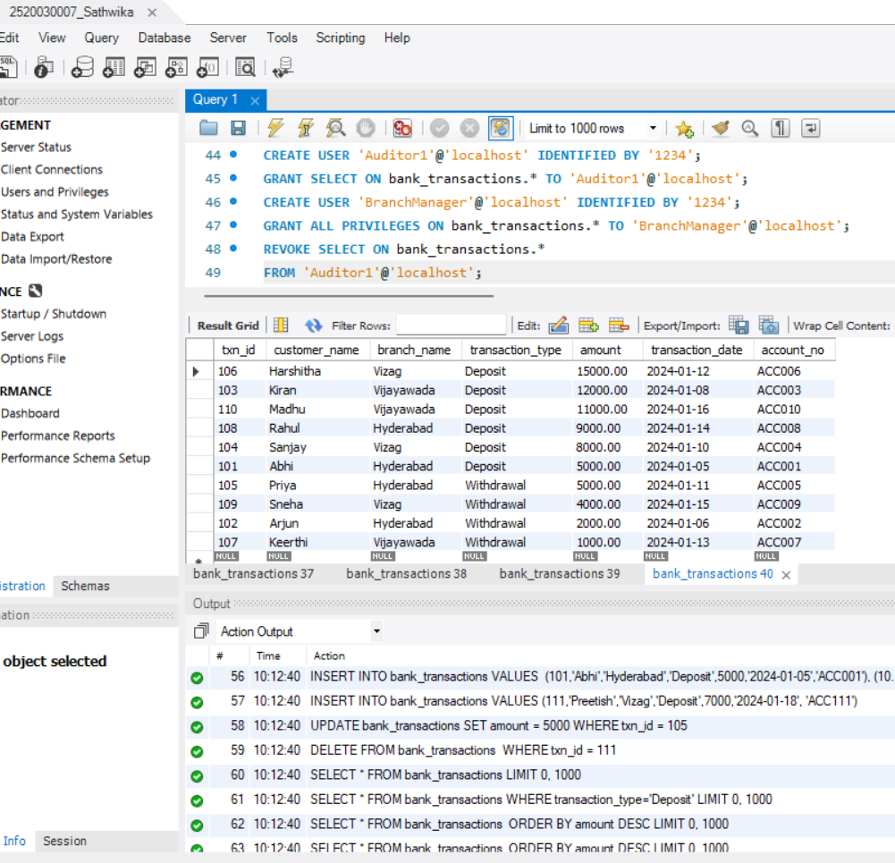

Step 16 — REVOKE ALL
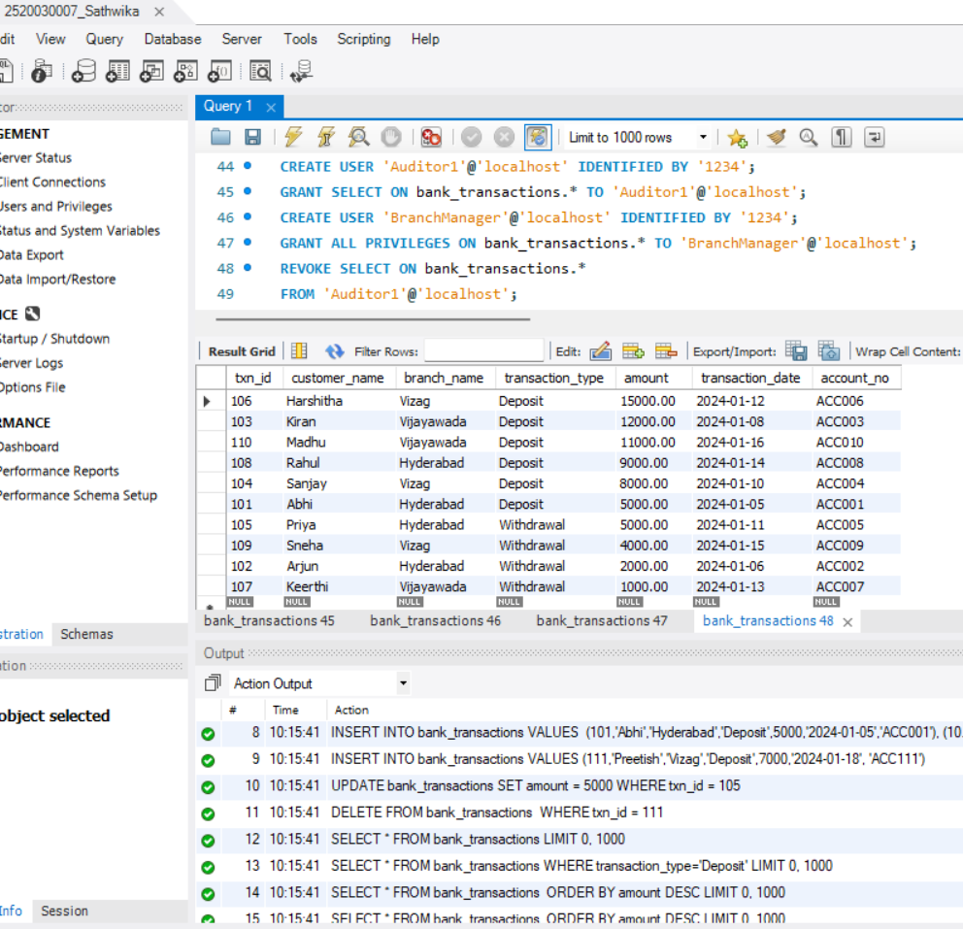
REVOKE ALL
ON bank_transactions FROM BranchManager;

SECTION 4 — TCL (Transaction Control Language)

Step 17 — COMMIT
UPDATE bank_transactions SET amount=6000
WHERE txn_id=101;

COMMIT;
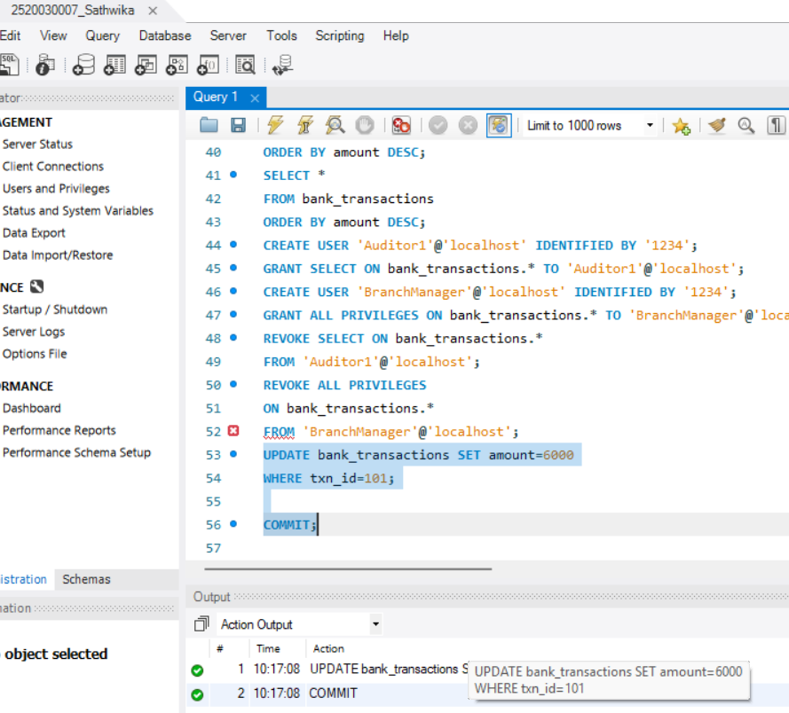

Step 18 — SAVEPOINT
SAVEPOINT Before_Update;
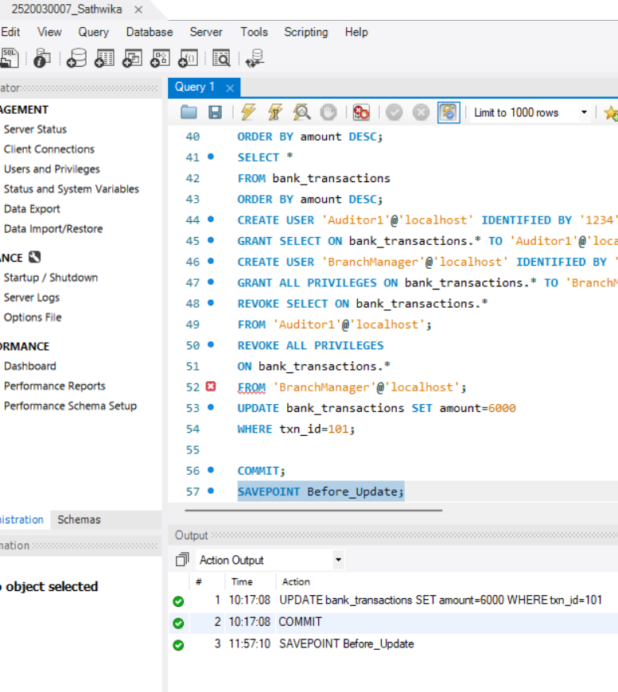

Step 19 — ROLLBACK TO SAVEPOINT
UPDATE bank_transactions SET amount=99999
WHERE txn_id=102; ROLLBACK TO Before_Update;
SELECT * FROM bank_transactions WHERE txn_id=102;

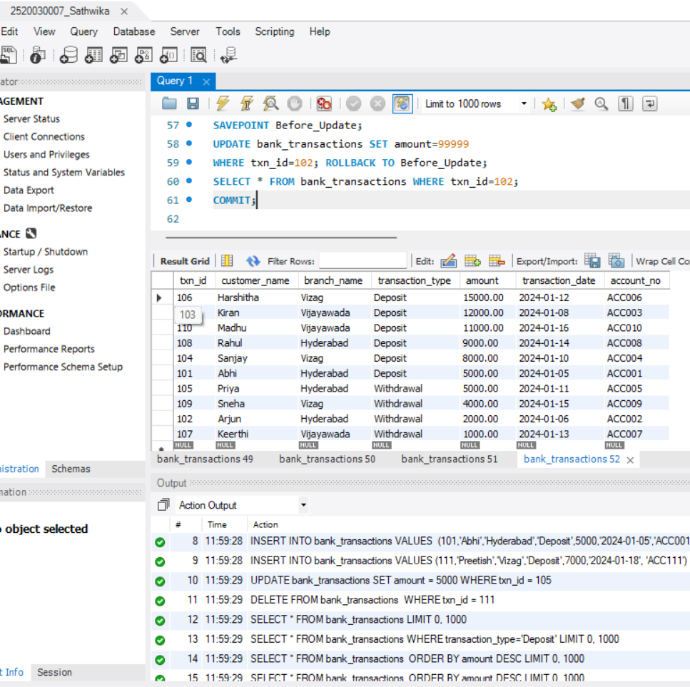

Step 20 — Full TCL Example
UPDATE bank_transactions SET amount=7000
WHERE txn_id=101; SAVEPOINT SP1;
UPDATE bank_transactions SET amount=9000
WHERE txn_id=102; ROLLBACK TO SP1; COMMIT;
SELECT * FROM bank_transactions WHERE txn_id IN (101,102);
